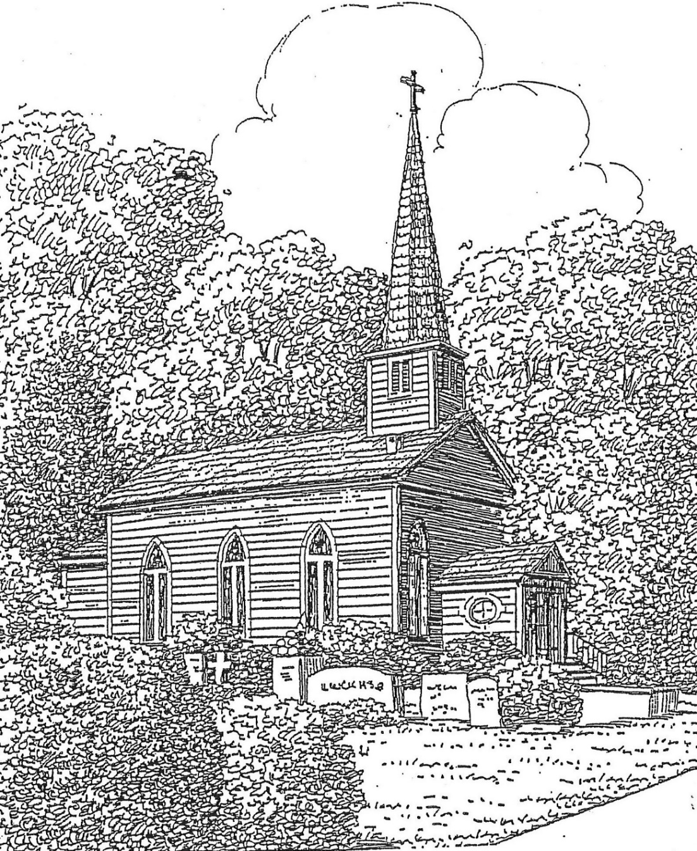

St. Thomas’ Episcopal Church
302 South Queen St.
Windsor, NC 27983
(252) 794-3420

www.stthomaswindsor.org
stthomasbiblestudy.com
email: stthomaschurch1@embarqmail.com

The Twentieth Sunday after Pentecost
October 10, 2021

The Holy Eucharist

Prelude Air from Water Music Suite Handel

Hymn #680 (vs. 1, 2 and 6) O God, our help in ages past St. Anne

The people standing, the Celebrant says
Blessed be God: Father, Son, and Holy Spirit.
People And blessed be his kingdom, now and for ever. Amen.
The Celebrant may say
Almighty God, to you all hearts are open, all desires known, and from you no secrets are hid: Cleanse the thoughts of our hearts by the inspiration of your Holy Spirit, that we may perfectly love you, and worthily magnify your holy Name;
through Christ our Lord. Amen.

S280 Gloria in excelsis Powell

Glory to God in the highest, and peace to his people on earth.

Lord God, heavenly King, almighty God and Father,
we worship you, we give you thanks, we praise you for your glory.

Lord Jesus Christ, only Son of the Father, Lord God, Lamb of God,
you take away the sin of the world: have mercy on us;
you are seated at the right hand of the Father: receive our prayer.

For you alone are the Holy One, you alone are the Lord,
you alone are the Most High, Jesus Christ, with the Holy Spirit,
in the glory of God the Father. Amen.

The Collect of the Day

The Celebrant says to the people: The Lord be with you.

People: And also with you.

Celebrant: Let us pray.

Lord, we pray that your grace may always precede and follow us, that we may continually be given to good works; through Jesus Christ our Lord, who lives and reigns with you and the Holy Spirit, one God, now and for ever. Amen.
The people sit.

The Word of God

The First Lesson Job 23:1-9, 16-17

Lector A reading from the Book of Job.

Job said:
"Today also my complaint is bitter;
his hand is heavy despite my groaning.
Oh, that I knew where I might find him,
that I might come even to his dwelling!
I would lay my case before him,
and fill my mouth with arguments.
I would learn what he would answer me,
and understand what he would say to me.
Would he contend with me in the greatness of his power?
No; but he would give heed to me.
There an upright person could reason with him,
and I should be acquitted forever by my judge.
"If I go forward, he is not there;
or backward, I cannot perceive him;
on the left he hides, and I cannot behold him;
I turn to the right, but I cannot see him.
God has made my heart faint;
the Almighty has terrified me;
If only I could vanish in darkness,
and thick darkness would cover my face!"
Lector The word of the Lord.
People Thanks be to God.

Psalm 22:1-15 (all chant the psalm on the following tone)
¹ My God, my God, why have you forsaken me? *
and are so far from my cry and from the words of my distress?
² O my God, I cry in the daytime, but you do not answer; *
by night as well, but I find no rest.
³ Yet you are the Holy One, *
enthroned upon the praises of Israel.
⁴ Our forefathers put their trust in you; *
they trusted, and you delivered them.
⁵ They cried out to you and were delivered; *
they trusted in you and were not put to shame.
⁶ But as for me, I am a worm and no man, *
scorned by all and despised by the people.
⁷ All who see me laugh me to scorn; *
they curl their lips and wag their heads, saying,
⁸ "He trusted in the Lord; let him deliver him; *
let him rescue him, if he delights in him."
⁹ Yet you are he who took me out of the womb, *
and kept me safe upon my mother's breast.
¹⁰ I have been entrusted to you ever since I was born; *
you were my God when I was still in my mother's womb.
¹¹ Be not far from me, for trouble is near, *
and there is none to help.
¹² Many young bulls encircle me; *
strong bulls of Bashan surround me.
¹³ They open wide their jaws at me, *
like a ravening and a roaring lion.
¹⁴ I am poured out like water; all my bones are out of joint; *
my heart within my breast is melting wax.
¹⁵ My mouth is dried out like a pot-sherd; my tongue sticks to the roof of my mouth; *
and you have laid me in the dust of the grave.

The Epistle Hebrews 4:12-16

A reading from the Book of Hebrews.

The word of God is living and active, sharper than any two-edged sword, piercing until it divides soul from spirit, joints from marrow; it is able to judge the thoughts and intentions of the heart. And before him no creature is hidden, but all are naked and laid bare to the eyes of the one to whom we must render an account.
Since, then, we have a great high priest who has passed through the heavens, Jesus, the Son of God, let us hold fast to our confession. For we do not have a high priest who is unable to sympathize with our weaknesses, but we have one who in every respect has been tested as we are, yet without sin. Let us therefore approach the throne of grace with boldness, so that we may receive mercy and find grace to help in time of need.
Lector The word of the Lord.
People Thanks be to God.

Sequence Hymn #655 (vs. 1 and 3) O Jesus, I have promised Nyland

The Holy Gospel Mark 10:17-31
Then, all standing, the Deacon or a Priest reads the Gospel, first saying
The Holy Gospel of our Lord Jesus Christ according to Mark.
People Glory to you, Lord Christ.

As Jesus was setting out on a journey, a man ran up and knelt before him, and asked him, “Good Teacher, what must I do to inherit eternal life?” Jesus said to him, “Why do you call me good? No one is good but God alone. You know the commandments: ‘You shall not murder; You shall not commit adultery; You shall not steal; You shall not bear false witness; You shall not defraud; Honor your father and mother.’” He said to him, “Teacher, I have kept all these since my youth.” Jesus, looking at him, loved him and said, “You lack one thing; go, sell what you own, and give the money to the poor, and you will have treasure in heaven; then come, follow me.” When he heard this, he was shocked and went away grieving, for he had many possessions.
Then Jesus looked around and said to his disciples, “How hard it will be for those who have wealth to enter the kingdom of God!” And the disciples were perplexed at these words. But Jesus said to them again, “Children, how hard it is to enter the kingdom of God! It is easier for a camel to go through the eye of a needle than for someone who is rich to enter the kingdom of God.” They were greatly astounded and said to one another, “Then who can be saved?” Jesus looked at them and said, “For mortals it is impossible, but not for God; for God all things are possible.”
Peter began to say to him, “Look, we have left everything and followed you.” Jesus said, “Truly I tell you, there is no one who has left house or brothers or sisters or mother or father or children or fields, for my sake and for the sake of the good news, who will not receive a hundredfold now in this age—houses, brothers and sisters, mothers and children, and fields with persecutions—and in the age to come eternal life. But many who are first will be last, and the last will be first.”

After the Gospel, the Reader says

The Gospel of the Lord.

People Praise to you, Lord Christ.

The Sermon

The congregation may stand.

The Nicene Creed

We believe in one God,
the Father, the Almighty,
maker of heaven and earth,
of all that is, seen and unseen.

We believe in one Lord, Jesus Christ,
the only Son of God,
eternally begotten of the Father,

God from God, Light from Light,
true God from true God,
begotten, not made,
of one Being with the Father.

Through him all things were made.

For us and for our salvation
he came down from heaven:
by the power of the Holy Spirit
he became incarnate from the Virgin Mary,
and was made man.

For our sake he was crucified under Pontius Pilate;
he suffered death and was buried.

On the third day he rose again
in accordance with the Scriptures;
he ascended into heaven
and is seated at the right hand of the Father.

He will come again in glory to judge the living and the dead,
and his kingdom will have no end.

We believe in the Holy Spirit, the Lord, the giver of life,
who proceeds from the Father and the Son.

With the Father and the Son he is worshiped and glorified.

He has spoken through the Prophets.

We believe in one holy catholic and apostolic Church.

We acknowledge one baptism for the forgiveness of sins.

We look for the resurrection of the dead,
and the life of the world to come. Amen.

The Prayers of the People Form VI
The Leader and People pray responsively
In peace, we pray to you, Lord God.
Silence
For all people in their daily life and work;
For our families, friends, and neighbors, and for those who are alone.
For this community, the nation, and the world;
For all who work for justice, freedom, and peace.
For the just and proper use of your creation;
For the victims of hunger, fear, injustice, and oppression.
For all who are in danger, sorrow, or any kind of trouble;
For those who minister to the sick, the friendless, and the needy.
For the peace and unity of the Church of God;
For all who proclaim the Gospel, and all who seek the Truth.
For Michael our Presiding Bishop, and Rob our Bishop; and for all bishops and other ministers, and especially Bonnie, our priest;
For all who serve God in his Church.
For the special needs and concerns of this congregation. For John Tolbert, Bobbie and Rendol Cobb, Julia Credle, Peggy Parker, Elsie Benson, Riley Raines, Mary Gillam, Rita Hoggard, Beth Bryant, Baron Chamblee, Emma Cobb, Daniel Perry, and others known to us.
Silence
The People may add their own petitions
Hear us, Lord;
For your mercy is great.
We thank you, Lord, for all the blessings of this life. This week in our Diocesan Cycle of Prayer we give thanks for Chaplains and Non-Parochial Clergy.
Silence
The People may add their own thanksgivings
We will exalt you, O God our King;
And praise your Name for ever and ever.
We pray for all who have died, especially John Tyler, that they may have a place in your eternal kingdom.
Silence
The People may add their own petitions
Lord, let your loving-kindness be upon them;
Who put their trust in you.
We pray to you also for the forgiveness of our sins.
Silence may be kept.
Leader and People
Have mercy upon us, most merciful Father;
in your compassion forgive us our sins,
known and unknown,
things done and left undone;
and so uphold us by your Spirit
that we may live and serve you in newness of life,
to the honor and glory of your Name;
through Jesus Christ our Lord. Amen.
The Bishop, when present, or the Priest, stands and says
Almighty God have mercy on you, forgive you all your sins through our Lord Jesus Christ, strengthen you in all goodness, and by the power of the Holy Spirit keep you in eternal life. Amen.

The Peace

The Celebrant says to the people
The peace of the Lord be always with you.
People And also with you.
(Please stay in place and share from a distance.)

The Holy Communion

Offertory Anthem O for a closer walk with God Caithness
(Please place your offering in the plate in the narthex as you enter or exit. During the anthem, the altar will be prepared for the Holy Communion.)

The Great Thanksgiving
Eucharistic Prayer A
The people remain standing. The Celebrant, whether bishop or priest says
The Lord be with you.

People And also with you.
Celebrant Lift up your hearts.

People We lift them to the Lord.
Celebrant Let us give thanks to the Lord our God.

People It is right to give him thanks and praise.
It is right, and a good and joyful thing, always and everywhere to give thanks to you, Father Almighty, Creator of heaven and earth. For you are the source of light and life, you made us in your image, and called us to new life in Jesus Christ our Lord. Therefore we praise you, joining our voices with Angels and Archangels and with all the company of heaven, who for ever sing this hymn to proclaim the glory of your Name:

S 125 Holy, holy, holy Lord, God of power and might, Proulx

heaven and earth are full of your glory.

Hosanna in the highest. Hosanna in the highest.

Blessed is he who comes in the name of the Lord.

Hosanna in the highest, Hosanna in the highest.

Then the Celebrant continues
Holy and gracious Father: In your infinite love you made us for yourself; and, when we had fallen into sin and become subject to evil and death, you, in your mercy, sent Jesus Christ, your only and eternal Son, to share our human nature, to live and die as one of us, to reconcile us to you, the God and Father of all. He stretched out his arms upon the cross, and offered himself in obedience to your will, a perfect sacrifice for the whole world. On the night he was handed over to suffering and death, our
Lord Jesus Christ took bread; and when he had given thanks to you, he broke it, and gave it to his disciples, and said, “Take, eat: This is my Body, which is given for you. Do this for the remembrance of me.”
After supper he took the cup of wine; and when he had given thanks, he gave it to them, and said, “Drink this, all of you: This is my Blood of the new Covenant, which is shed for you and for many for the forgiveness of sins. Whenever you drink it, do this for the remembrance of me.”
Therefore we proclaim the mystery of faith:
Celebrant and People

Christ has died. Christ is risen. Christ will come again.

The Celebrant continues
We celebrate the memorial of our redemption, O Father, in this sacrifice of praise and thanksgiving. Recalling his death, resurrection, and ascension, we offer you these gifts. Sanctify them by your Holy Spirit to be for your people the Body and Blood of your Son, the holy food and drink of new and unending life in him. Sanctify us also that we may faithfully receive this holy Sacrament, and serve you in unity, constancy, and peace; and at the last day bring us with all your saints into the joy of your eternal kingdom.
All this we ask through your Son Jesus Christ. By him, and with him, and in him, in the unity of the Holy Spirit all honor and glory is yours, Almighty Father, now and for ever. AMEN.

And now, as our Savior Christ has taught us, we are bold to say,

Our Father, who art in heaven, hallowed be thy Name,
thy kingdom come, thy will be done,
on earth as it is in heaven.

Give us this day our daily bread.

And forgive us our trespasses, as we forgive those
who trespass against us.

And lead us not into temptation, but deliver us from evil.

For thine is the kingdom, and the power, and the glory,
for ever and ever. Amen

The Breaking of the Bread The Celebrant breaks the consecrated Bread. A period of silence is kept. Then may be sung or said
Celebrant: Alleluia. Christ our Passover is sacrificed for us;

People: Therefore let us keep the feast. Alleluia.

Facing the people, the Celebrant says the following Invitation:
The Gifts of God for the People of God. Take them in remembrance that Christ died for you, and feed on him in your hearts by faith, with thanksgiving.
(Please stay in place, and the bread will be brought to you. There is a small trash can in the narthex for the wrapper when you exit. The chalice will remain on the altar, per diocesan guidelines.)

Post Communion Prayer
After Communion, the Celebrant says:
Let us pray.
Celebrant and People:
Eternal God, heavenly Father,
you have graciously accepted us as living members
of your Son our Savior Jesus Christ,
and you have fed us with spiritual food
in the Sacrament of his Body and Blood.
Send us now into the world in peace,
and grant us strength and courage
to love and serve you
with gladness and singleness of heart;
through Christ our Lord. Amen.

The Bishop when present, or the Priest, may bless the people.
Hymn #488 (vs. 1 and 3) Be thou my vision, O Lord of my heart Slane

The Deacon, or the Celebrant, dismisses them

People Thanks be to God.

Postlude Allegro Vivace from Water Music Suite Handel

The altar flowers are given to the Glory of God by Tra Perry.

The Ministers of the Liturgy

Celebrant: The Rev. Bonnie J. Smith Organist: Tom Parker
Lector: Jaquelin Perry Soloist: Mike Spruill
Altar Guild: Kristy Copeland and Rosanna Rhea
Hostesses: Jaquelin Perry, Gina Rascoe, and Karen Ray
Counters: Jaquelin Perry and Mike Spruill
Ushers: Wood Farless and Chip Warren

ANNOUNCEMENTS

Crayons, coloring pages, and children’s bulletins are available in the narthex.

The memorial service for Sr. Warden John Tyler is scheduled for Thursday, October 14, at 4:00 p.m. at the St. Thomas outdoor altar. A reception on the lawn will follow.

Bishop Skirving’s visitation with St. Thomas’ Church is scheduled for Sunday, October 24 at 11:00 a.m. By custom, the loose offering on that day will be given to the Bishop’s Discretionary Fund to be used for needs of the Church not covered by the diocesan budget. A reception on the lawn will follow worship.

Please take your printed bulletin with you or drop it into the designated recycling bin. Please visit outside.

The altar flower signup sheet may be found here: https://stthomasbiblestudy.com/altar-flowers-volunteer/

The vestry has instituted the following COVID safeguards: pews are separated for social distancing; you are asked to wear a mask as you enter and exit and when you are in close proximity to others; and we will sing 2-3 verses of the hymns.

The CDC COVID data county view states that “everyone in Bertie County should wear a mask in public, indoor settings.”

From the September 29 diocesan guidelines: “All involved in ministries with children, and particularly with children who are too young to be vaccinated, should be vaccinated, and should continue to practice physical distancing, masking and other recommended protocols.”

