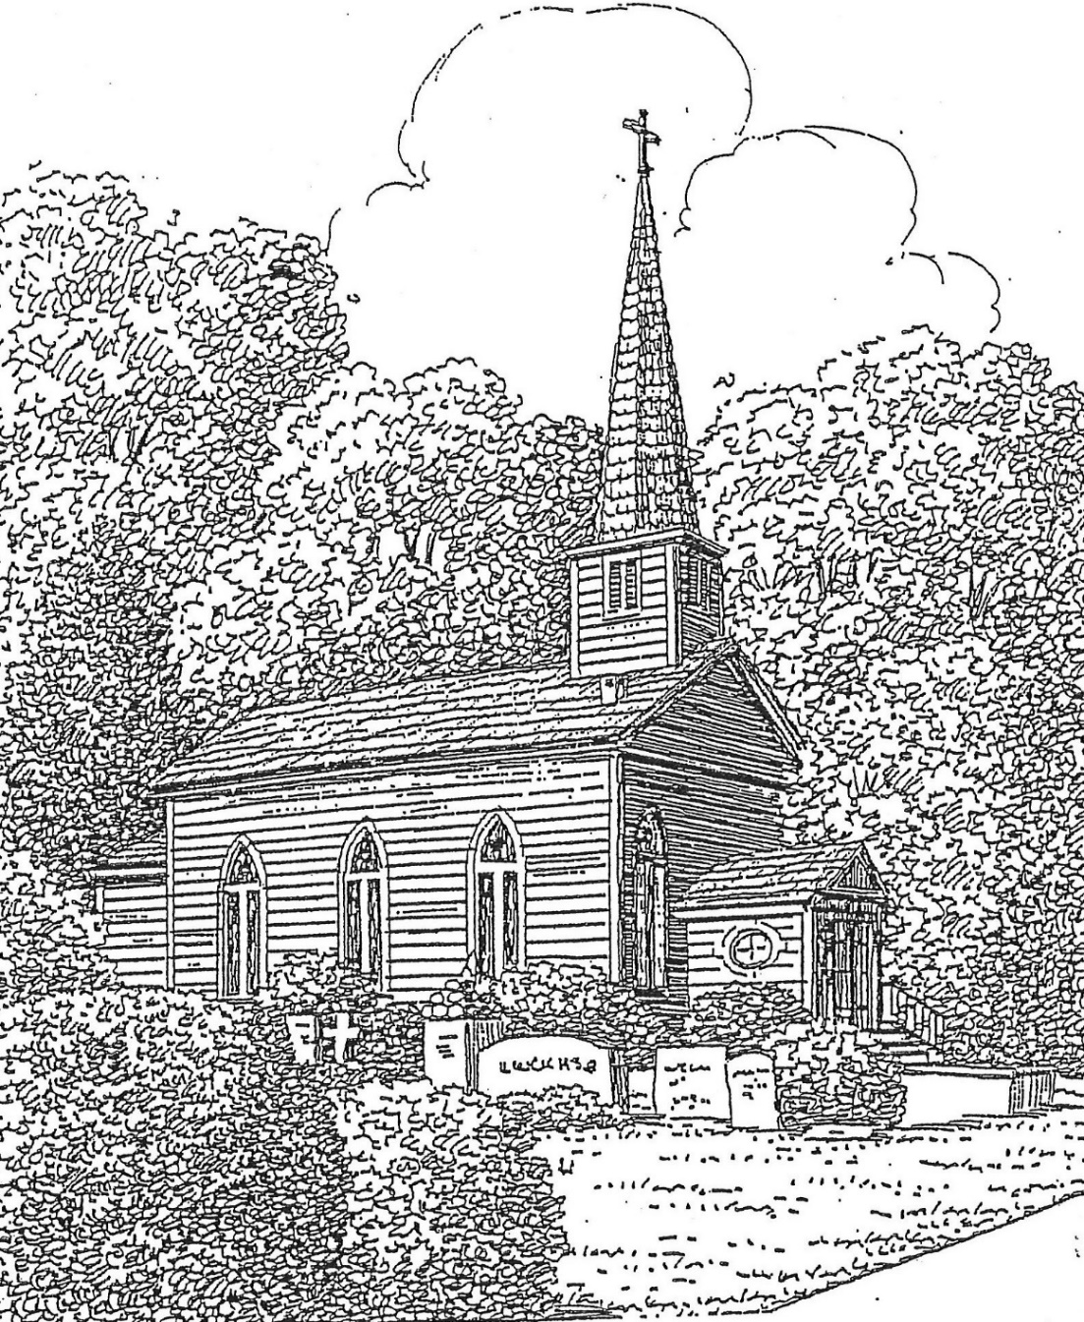

St. Thomas’ Episcopal Church
302 South Queen St.
Windsor, NC 27983
(252) 794-3420

www.stthomaswindsor.org
stthomasbiblestudy.com
email: stthomaschurch1@embarqmail.com

The First Sunday after Christmas

December 27, 2020
The Festival of Lessons and Carols

Prelude Pastoral Symphony Handel

A Bidding Prayer
Presider
Dear People of God: In this Christmas season, let it be our duty and delight to hear once more the message of the Angels, to go to Bethlehem and see the Son of God lying in a manger.
Let us hear and heed in Holy Scripture the story of God’s loving purpose from the time of our rebellion against him until the glorious redemption brought to us by his holy Child Jesus, and let us make this place glad with carols of praise.
But first, let us pray for the needs of his whole world, for peace and justice on earth, for the unity and mission of the Church for which he died, and especially for his Church in our country and in this county.
And because he particularly loves them, let us remember in his name the poor and helpless, the cold, the hungry and the oppressed, the sick and those who mourn, the lonely and unloved, the aged and little children, as well as all those who do not know and love the Lord Jesus Christ.
Finally, let us remember before God his pure and lowly Mother, and that whole multitude which no one can number, whose hope was in the Word made flesh, and with whom, in Jesus, we are one for evermore.
And now, to sum up all these petitions, let us pray in the words which Christ himself has taught us, saying:

Presider and People
Our Father, who art in heaven,
hallowed be thy Name,
thy kingdom come,
thy will be done,
on earth as it is in heaven.
Give us this day our daily bread.
And forgive us our trespasses
as we forgive those who trespass against us.
And lead us not into temptation,
but deliver us from evil.
For thine is the kingdom,
and the power, and the glory,
for ever and ever. Amen.

Presider
The Almighty God bless us with his grace; Christ give us the joys of everlasting life; and to the fellowship of the citizens above may the King of Angels bring us all. Amen.

The Lessons and Carols

The First Lesson Genesis 3:1-15 (Adam and Eve rebel against God and are cast out of the Garden of Eden) read by Michael Spruill

Lector A reading from the book of Genesis.

Now the serpent was more crafty than any other wild animal that the LORD God had made. He said to the woman, "Did God say, `You shall not eat from any tree in the garden'?" The woman said to the serpent, "We may eat of the fruit of the trees in the garden; but God said, `You shall not eat of the fruit of the tree that is in the middle of the garden, nor shall you touch it, or you shall die.'" But the serpent said to the woman, "You will not die; for God knows that when you eat of it your eyes will be opened, and you will be like God, knowing good and evil." So when the woman saw that the tree was good for food, and that it was a delight to the eyes, and that the tree was to be desired to make one wise, she took of its fruit and ate; and she also gave some to her husband, who was with her, and he ate. Then the eyes of both were opened, and they knew that they were naked; and they sewed fig leaves together and made loincloths for themselves.
They heard the sound of the LORD God walking in the garden at the time of the evening breeze, and the man and his wife hid themselves from the presence of the LORD God among the trees of the garden. But the LORD God called to the man, and said to him, "Where are you?" He said, "I heard the sound of you in the garden, and I was afraid, because I was naked; and I hid myself." He said, "Who told you that you were naked? Have you eaten from the tree of which I commanded you not to eat?" The man said, "The woman whom you gave to be with me, she gave me fruit from the tree, and I ate." Then the LORD God said to the woman, "What is this that you have done?" The woman said, "The serpent tricked me, and I ate." The LORD God said to the serpent,
"Because you have done this,
cursed are you among all animals
and among all wild creatures;
upon your belly you shall go,
and dust you shall eat
all the days of your life.
I will put enmity between you and the woman,
and between your offspring and hers;
he will strike your head,
and you will strike his heel."

Lector The word of the Lord.
People Thanks be to God.

Anthem Creator Of The Stars Of Night Conditor alme siderum

The Second Lesson Isaiah 40:1-11 (God comforts his people and calls on them to prepare for redemption) read by John Hill

Lector A reading from the book of Isaiah.

Comfort, O comfort my people,
says your God.
Speak tenderly to Jerusalem,
and cry to her
that she has served her term,
that her penalty is paid,
that she has received from the LORD's hand
double for all her sins.
A voice cries out:
"In the wilderness prepare the way of the LORD,
make straight in the desert a highway for our God.
Every valley shall be lifted up,
and every mountain and hill be made low;
the uneven ground shall become level,
and the rough places a plain.
Then the glory of the LORD shall be revealed,
and all people shall see it together,
for the mouth of the LORD has spoken."
A voice says, "Cry out!"
And I said, "What shall I cry?"
All people are grass,
their constancy is like the flower of the field.
The grass withers, the flower fades,
when the breath of the LORD blows upon it;
surely the people are grass.
The grass withers, the flower fades;
but the word of our God will stand forever.
Get you up to a high mountain,
O Zion, herald of good tidings;
lift up your voice with strength,
O Jerusalem, herald of good tidings,
lift it up, do not fear;
say to the cities of Judah,
"Here is your God!"
See, the Lord GOD comes with might,
and his arm rules for him;
his reward is with him,
and his recompense before him.
He will feed his flock like a shepherd;
he will gather the lambs in his arms,
and carry them in his bosom,
and gently lead the mother sheep.

Lector The word of the Lord.
People Thanks be to God

Anthem There’s A Voice In The Wilderness Crying Ascension

The Third Lesson Isaiah 35:1-10 (The prophet proclaims that God will come and save us) read by Jaquelin Perry

Lector A reading from the book of Isaiah.

The wilderness and the dry land shall be glad,
the desert shall rejoice and blossom;
like the crocus it shall blossom abundantly,
and rejoice with joy and singing.
The glory of Lebanon shall be given to it,
the majesty of Carmel and Sharon.
They shall see the glory of the LORD,
the majesty of our God.
Strengthen the weak hands,
and make firm the feeble knees.
Say to those who are of a fearful heart,
"Be strong, do not fear!
Here is your God.
He will come with vengeance,
with terrible recompense.
He will come and save you."
Then the eyes of the blind shall be opened,
and the ears of the deaf unstopped;
then the lame shall leap like a deer,
and the tongue of the speechless sing for joy.
For waters shall break forth in the wilderness,
and streams in the desert;
the burning sand shall become a pool,
and the thirsty ground springs of water;
the haunt of jackals shall become a swamp,
the grass shall become reeds and rushes.
A highway shall be there,
and it shall be called the Holy Way;
the unclean shall not travel on it,
but it shall be for God's people;
no traveler, not even fools, shall go astray.
No lion shall be there,
nor shall any ravenous beast come up on it;
they shall not be found there,
but the redeemed shall walk there.
And the ransomed of the LORD shall return,
and come to Zion with singing;
everlasting joy shall be upon their heads;
they shall obtain joy and gladness,
and sorrow and sighing shall flee away.

Lector The word of the Lord.
People Thanks be to God

Anthem Lo, How A Rose E’er Blooming Es ist ein Ros

The Fourth Lesson Micah 5:2-4 (The one who is to rule Israel will be born in the village of Bethlehem) read by Jane Hall

Lector A reading from the book of Micah.

But you, O Bethlehem of Ephrathah,
who are one of the little clans of Judah,
from you shall come forth for me
one who is to rule in Israel,
whose origin is from of old,
from ancient days.
Therefore he shall give them up until the time
when she who is in labor has brought forth;
then the rest of his kindred shall return
to the people of Israel.
And he shall stand and feed his flock in the strength of the LORD,
in the majesty of the name of the LORD his God.
And they shall live secure, for now he shall be great
to the ends of the earth.

Lector The word of the Lord.
People Thanks be to God.

Anthem O Little Town of Bethlehem St. Louis

The Fifth Lesson Isaiah 11:1-9 (The Spirit of the Lord will rest upon the Holy One) read by Patti Farless

Lector A reading from the book of Isaiah.

A shoot shall come out from the stump of Jesse,
and a branch shall grow out of his roots.
The spirit of the Lord shall rest on him,
the spirit of wisdom and understanding,
the spirit of counsel and might,
the spirit of knowledge and the fear of the Lord.
His delight shall be in the fear of the Lord.
He shall not judge by what his eyes see,
or decide by what his ears hear;
but with righteousness he shall judge the poor,
and decide with equity for the meek of the earth;
he shall strike the earth with the rod of his mouth,
and with the breath of his lips he shall kill the wicked.
Righteousness shall be the belt around his waist,
and faithfulness the belt around his loins.
The wolf shall live with the lamb,
the leopard shall lie down with the kid,
the calf and the lion and the fatling together,
and a little child shall lead them.
The cow and the bear shall graze,
their young shall lie down together; and the lion shall eat straw like the
ox.
The nursing child shall play over the hole of the asp,
and the weaned child shall put its hand on the adder's den.
They will not hurt or destroy
on all my holy mountain;
for the earth will be full of the knowledge of the Lord
as the waters cover the sea.
On that day the root of Jesse shall stand as a signal to the peoples; the nations shall inquire of him, and his dwelling shall be glorious.

Lector The word of the Lord.
People Thanks be to God.

Anthem O Come, O Come, Emmanuel Veni, veni, Emmanuel

The Sixth Lesson Isaiah 65:17-25 (God promises a new heaven and a new earth) read by Karen Ray

Lector A reading from the book of Isaiah.

For I am about to create new heavens
and a new earth;
the former things shall not be remembered
or come to mind.
But be glad and rejoice forever
in what I am creating;
for I am about to create Jerusalem as a joy,
and its people as a delight.
I will rejoice in Jerusalem,
and delight in my people;
no more shall the sound of weeping be heard in it,
or the cry of distress.
No more shall there be in it
an infant that lives but a few days,
or an old person who does not live out a lifetime;
for one who dies at a hundred years will be considered a youth,
and one who falls short of a hundred will be considered accursed.
They shall build houses and inhabit them;
they shall plant vineyards and eat their fruit.
They shall not build and another inhabit;
they shall not plant and another eat;
for like the days of a tree shall the days of my people be,
and my chosen shall long enjoy the work of their hands.
They shall not labor in vain,
or bear children for calamity;
for they shall be offspring blessed by the LORD--
and their descendants as well.
Before they call I will answer,
while they are yet speaking I will hear.
The wolf and the lamb shall feed together,
the lion shall eat straw like the ox;
but the serpent-- its food shall be dust!
They shall not hurt or destroy
on all my holy mountain, says the LORD.

Lector The word of the Lord.
People Thanks be to God.

Anthem Come Thou Long Expected Jesus Stuggart

The Seventh Lesson Luke 1:26-38 (The Angel Gabriel announces to the Virgin Mary that she will bear the Son of the Most High)

A reading from the Holy Gospel according to Luke.

In the sixth month the angel Gabriel was sent by God to a town in Galilee called Nazareth, to a virgin engaged to a man whose name was Joseph, of the house of David. The virgin’s name was Mary. And he came to her and said, “Greetings, favored one! The Lord is with you.” But she was much perplexed by his words and pondered what sort of greeting this might be. The angel said to her, “Do not be afraid, Mary, for you have found favor with God. And now, you will conceive in your womb and bear a son, and you will name him Jesus. He will be great, and will be called the Son of the Most High, and the Lord God will give to him the throne of his ancestor David. He will reign over the house of Jacob forever, and of his kingdom there will be no end.” Mary said to the angel, “How can this be, since I am a virgin?” The angel said to her, “The Holy Spirit will come upon you, and the power of the Most High will overshadow you; therefore the child to be born will be holy; he will be called Son of God. And now, your relative Elizabeth in her old age has also conceived a son; and this is the sixth month for her who was said to be barren. For nothing will be impossible with God.” Then Mary said, “Here am I, the servant of the Lord; let it be with me according to your word.” Then the angel departed from her.
Lector The word of the Lord.
People Thanks be to God.

Anthem The Angel Gabriel From Heaven Came Gabriel’s Message

The Collect of the Day
Almighty God, you have poured upon us the new light of your incarnate Word: Grant that this light, enkindled in our hearts, may shine forth in our lives; through Jesus Christ our Lord, who lives and reigns with you, in the unity of the Holy Spirit, one God, now and for ever. Amen.

The Officiant may then conclude with the following
May the God of hope fill us with all joy and peace in believing through the power of the Holy Spirit. Amen. Romans 15:13

Postlude And The Glory Of The Lord Handel

MINISTERS OF THE LITURGY
Officiant: The Rev. Bonnie Smith
Organist: Tom Parker
Altar: Cathy Wilson, Della Cherry, Rosanna Rhea
Lectors: Patti Farless, Jane Hall, John Hill, Jaquelin Perry, Karen Ray, Michael Spruill
Soloists: Clara Blanchard, John Hill, Tom Parker, Karen Ray, Joe Rhea, Mike Spruill
Usher: Bob Capehart
Hostesses: Cathy Wilson, Nancy Joyner, and Clara Blanchard
Money Counters: Rosanna Rhea and Jane Hall

ANNOUNCEMENTS
Thank you for observing proper precautions for any gatherings during COVID-19: wear a mask, wash your hands, and wait 6 feet apart between households.

Under COVID-19 guidelines, the following changes must be made to our worship:
- Offering plates will not be passed. Please deposit your offering in the designated basket as you arrive or exit. Or you may mail your offering to St. Thomas’ Episcopal Church, PO Box 400, Windsor, NC 27983.
- Congregational and choral singing are not permitted. A soloist is allowed, while physical distancing and wearing a face covering.
- Nursery care and children’s Sunday School cannot be offered. New coloring and activity sheets are available each Sunday.
- No receptions or meals may be offered before or after worship.
- Please limit use of church restrooms.

Please take your printed bulletin home or drop it in the designated recycling container.

Small water bottles are available for your use.

Thank you to everyone who planned, participated in, and attended the Christmas pageant and Service of Light on December 23.

Thank you to Dickie Hall, Free Perry, and Cham Trowell who are completing 3 years of vestry service. Congratulations to Pat Ivey, Steve Trowell, and John Tyler who were elected to the vestry at the annual meeting.
During the vestry meeting on December 21, Joe Rhea submitted his resignation as a vestry member. The vestry elected Janet Capehart to fill the remainder of his term.

Would you be willing to serve as a delegate to diocesan convention on Saturday, February 13 via Zoom and smartphone for 3-4 hours from the comfort of your own home? Thank you to John Tyler who has been elected by the vestry. We are allotted two more delegates. Please contact the priest no later than Monday, December 28, in order to meet the registration deadline.

The vestry and Bishop Skirving have agreed to postpone his visitation, which had been scheduled for January.

You are invited to join the diocesan-wide “Journey through East Carolina” through February 7, 2021. Details are available at https://www.ecdio.org/journey.html

