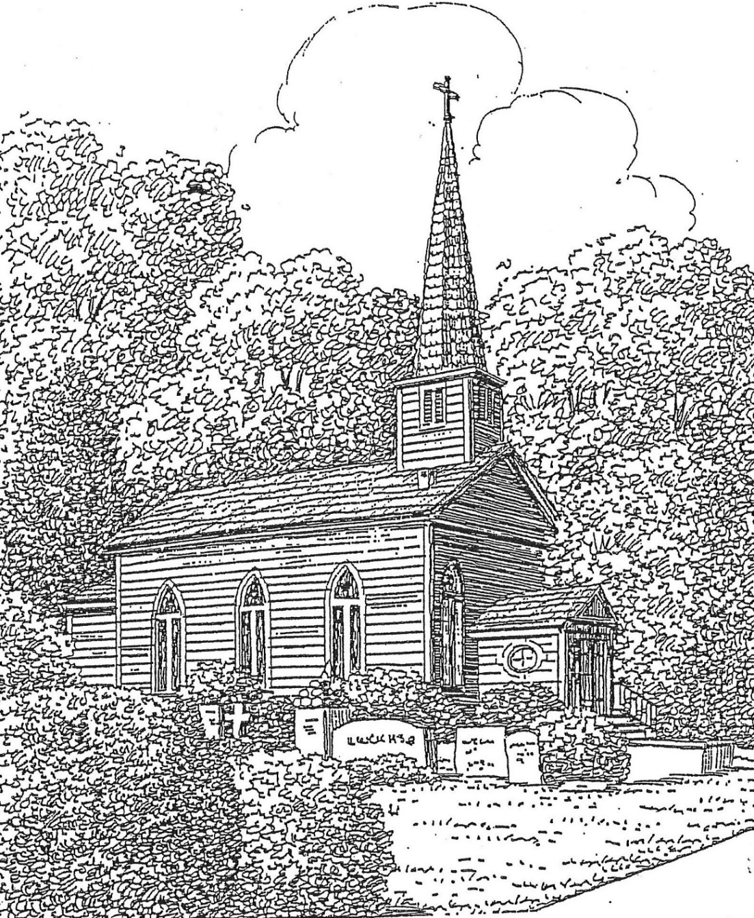

St. Thomas’ Episcopal Church
302 South Queen St.
Windsor, NC 27983
(252) 794-3420

www.stthomaswindsor.org
stthomasbiblestudy.com
email: stthomaschurch1@embarqmail.com

The Sixteenth Sunday after Pentecost
September 20, 2020

Morning Prayer: Rite Two

Prelude Praise, My Soul, the King of Heaven Goss

Opening sentence p. 78
Grace to you and peace from God our Father and from the Lord Jesus Christ. Philippians 1:2

Confession of Sin
Let us confess our sins against God and our neighbor.

Silence may be kept.

Minister and People:

Most merciful God,
we confess that we have sinned against you
in thought, word, and deed,
by what we have done,
and by what we have left undone.

We have not loved you with our whole heart;
we have not loved our neighbors as ourselves.

We are truly sorry and we humbly repent.

For the sake of your Son Jesus Christ,
have mercy on us and forgive us;
that we may delight in your will,
and walk in your ways,
to the glory of your Name. Amen.

The Bishop when present, or the Priest, stands and says
Almighty God have mercy on you, forgive you all your sins through our Lord Jesus Christ, strengthen you in all goodness, and by the power of the Holy Spirit keep you in eternal life. Amen.

The Invitatory and Psalter

Officiant Lord, open our lips. p. 80

People And our mouth shall proclaim your praise.

Officiant and People

Glory to the Father, and to the Son, and to the Holy Spirit:

As it was in the beginning, is now, and will be for ever. Amen.

Worship the Lord in the beauty of holiness: Come let us adore him.

The Venite (all recite in unison) p. 82
Come, let us sing to the Lord; *
let us shout for joy to the Rock of our salvation.
Let us come before his presence with thanksgiving *
and raise a loud shout to him with psalms.
For the Lord is a great God, *
and a great King above all gods.
In his hand are the caverns of the earth, *
and the heights of the hills are his also.
The sea is his, for he made it, *
and his hands have molded the dry land.
Come, let us bow down, and bend the knee, *
and kneel before the Lord our Maker.
For he is our God,
and we are the people of his pasture and the sheep of his hand. *
Oh, that today you would hearken to his voice!

Psalm 105:1-6, 37-45 (read responsively by whole verse)
¹ Give thanks to the Lord and call upon his Name; *
make known his deeds among the peoples.
² Sing to him, sing praises to him, *
and speak of all his marvelous works.
³ Glory in his holy Name; *
let the hearts of those who seek the Lord rejoice.
⁴ Search for the Lord and his strength; *
continually seek his face.
⁵ Remember the marvels he has done, *
his wonders and the judgments of his mouth,
⁶ O offspring of Abraham his servant, *
O children of Jacob his chosen.
³⁷ He led out his people with silver and gold; *
in all their tribes there was not one that stumbled.
³⁸ Egypt was glad of their going, *
because they were afraid of them.
³⁹ He spread out a cloud for a covering *
and a fire to give light in the night season.
⁴⁰ They asked, and quails appeared, *
and he satisfied them with bread from heaven.
⁴¹ He opened the rock, and water flowed, *
so the river ran in the dry places.
⁴² For God remembered his holy word *
and Abraham his servant.
⁴³ So he led forth his people with gladness, *
his chosen with shouts of joy.
⁴⁴ He gave his people the lands of the nations, *
and they took the fruit of others' toil,
⁴⁵ That they might keep his statutes *
and observe his laws. Hallelujah!
Glory to the Father, and to the Son, and to the Holy Spirit: *
as it was in the beginning, is now, and will be for ever. A-men.

The First Lesson Exodus 16:2-15

A reading from the book of Exodus.

The whole congregation of the Israelites complained against Moses and Aaron in the wilderness. The Israelites said to them, “If only we had died by the hand of the Lord in the land of Egypt, when we sat by the fleshpots and ate our fill of bread; for you have brought us out into this wilderness to kill this whole assembly with hunger.”
Then the Lord said to Moses, “I am going to rain bread from heaven for you, and each day the people shall go out and gather enough for that day. In that way I will test them, whether they will follow my instruction or not. On the sixth day, when they prepare what they bring in, it will be twice as much as they gather on other days.” So Moses and Aaron said to all the Israelites, “In the evening you shall know that it was the Lord who brought you out of the land of Egypt, and in the morning you shall see the glory of the Lord, because he has heard your complaining against the Lord. For what are we, that you complain against us?” And Moses said, “When the Lord gives you meat to eat in the evening and your fill of bread in the morning, because the Lord has heard the complaining that you utter against him—what are we? Your complaining is not against us but against the Lord.”
Then Moses said to Aaron, “Say to the whole congregation of the Israelites, ‘Draw near to the Lord, for he has heard your complaining.’“ And as Aaron spoke to the whole congregation of the Israelites, they looked toward the wilderness, and the glory of the Lord appeared in the cloud. The Lord spoke to Moses and said, “I have heard the complaining of the Israelites; say to them, ‘At twilight you shall eat meat, and in the morning you shall have your fill of bread; then you shall know that I am the Lord your God.’“
In the evening quails came up and covered the camp; and in the morning there was a layer of dew around the camp. When the layer of dew lifted, there on the surface of the wilderness was a fine flaky substance, as fine as frost on the ground. When the Israelites saw it, they said to one another, “What is it?” For they did not know what it was. Moses said to them, “It is the bread that the Lord has given you to eat.”
Lector The word of the Lord.
People Thanks be to God
Canticle 9 The First Song of Isaiah Isaiah 12:2-6 (all recite in unison) p. 86
Surely, it is God who saves me; *
I will trust in him and not be afraid.
For the Lord is my stronghold and my sure defense, *
and he will be my Savior.
Therefore you shall draw water with rejoicing *
from the springs of salvation.
And on that day you shall say, *
Give thanks to the Lord and call upon his Name;
Make his deeds known among the peoples; *
see that they remember that his Name is exalted.
Sing the praises of the Lord, for he has done great things, *
and this is known in all the world.
Cry aloud, inhabitants of Zion, ring out your joy, *
for the great one in the midst of you is the Holy One of Israel.
Glory to the Father, and to the Son, and to the Holy Spirit: *
as it was in the beginning, is now, and will be for ever. Amen.

The Second Lesson Philippians 1:21-30

A reading from the Letter of Paul to the Philippians.

To me, living is Christ and dying is gain. If I am to live in the flesh, that means fruitful labor for me; and I do not know which I prefer. I am hard pressed between the two: my desire is to depart and be with Christ, for that is far better; but to remain in the flesh is more necessary for you. Since I am convinced of this, I know that I will remain and continue with all of you for your progress and joy in faith, so that I may share abundantly in your boasting in Christ Jesus when I come to you again.
Only, live your life in a manner worthy of the gospel of Christ, so that, whether I come and see you or am absent and hear about you, I will know that you are standing firm in one spirit, striving side by side with one mind for the faith of the gospel, and are in no way intimidated by your opponents. For them this is evidence of their destruction, but of your salvation. And this is God's doing. For he has graciously granted you the privilege not only of believing in Christ, but of suffering for him as well-- since you are having the same struggle that you saw I had and now hear that I still have.
Lector The word of the Lord.
People Thanks be to God
Canticle 10 The Second Song of Isaiah Isaiah 55:6-11 (all recite in unison) p. 86
Seek the Lord while he wills to be found; *
call upon him when he draws near.
Let the wicked forsake their ways *
and the evil ones their thoughts;
And let them turn to the Lord, and he will have compassion, *
and to our God, for he will richly pardon.
For my thoughts are not your thoughts, *
nor your ways my ways, says the Lord.
For as the heavens are higher than the earth, *
so are my ways higher than your ways,
and my thoughts than your thoughts. For as rain and snow fall from the heavens *
and return not again, but water the earth,
Bringing forth life and giving growth, *
seed for sowing and bread for eating,
So is my word that goes forth from my mouth; *
it will not return to me empty;
But it will accomplish that which I have purposed, *
and prosper in that for which I sent it.
Glory to the Father, and to the Son, and to the Holy Spirit: *
as it was in the beginning, is now, and will be for ever. Amen.

The Gospel Matthew 20:1-16

A reading from the Gospel of Matthew.

Jesus said, “The kingdom of heaven is like a landowner who went out early in the morning to hire laborers for his vineyard. After agreeing with the laborers for the usual daily wage, he sent them into his vineyard. When he went out about nine o’clock, he saw others standing idle in the marketplace; and he said to them, ‘You also go into the vineyard, and I will pay you whatever is right.’ So they went. When he went out again about noon and about three o’clock, he did the same. And about five o’clock he went out and found others standing around; and he said to them, ‘Why are you standing here idle all day?’ They said to him, ‘Because no one has hired us.’ He said to them, ‘You also go into the vineyard.’ When evening came, the owner of the vineyard said to his manager, ‘Call the laborers and give them their pay, beginning with the last and then going to the first.’ When those hired about five o’clock came, each of them received the usual daily wage. Now when the first came, they thought they would receive more; but each of them also received the usual daily wage. And when they received it, they grumbled against the landowner, saying, ‘These last worked only one hour, and you have made them equal to us who have borne the burden of the day and the scorching heat.’ But he replied to one of them, ‘Friend, I am doing you no wrong; did you not agree with me for the usual daily wage? Take what belongs to you and go; I choose to give to this last the same as I give to you. Am I not allowed to do what I choose with what belongs to me? Or are you envious because I am generous?’ So the last will be first, and the first will be last.”
Lector The word of the Lord.
People Thanks be to God

Sermon

The Apostles’ Creed p. 96
Officiant and People together

I believe in God, the Father almighty,
creator of heaven and earth.

I believe in Jesus Christ, his only Son, our Lord.

He was conceived by the power of the Holy Spirit
and born of the Virgin Mary.

He suffered under Pontius Pilate,
was crucified, died, and was buried.

He descended to the dead.

On the third day he rose again.

He ascended into heaven,
and is seated at the right hand of the Father.

He will come again to judge the living and the dead.

I believe in the Holy Spirit,
the holy catholic Church,
the communion of saints,
the forgiveness of sins,
the resurrection of the body,
and the life everlasting. Amen.

The Prayers

Officiant The Lord be with you. p. 97

People And also with you.
Officiant Let us pray.

Our Father, who art in heaven,
hallowed be thy Name, thy kingdom come,
thy will be done, on earth as it is in heaven.
Give us this day our daily bread.
And forgive us our trespasses,
as we forgive those who trespass against us.
And lead us not into temptation,
but deliver us from evil.
For thine is the kingdom,
and the power, and the glory, for ever and ever. Amen.

Then follows one of these sets of Suffrages

A
V. Show us your mercy, O Lord;

R. And grant us your salvation.
V. Clothe your ministers with righteousness;

R. Let your people sing with joy.
V. Give peace, O Lord, in all the world;

R. For only in you can we live in safety.
V. Lord, keep this nation under your care;

R. And guide us in the way of justice and truth.
V. Let your way be known upon earth;

R. Your saving health among all nations.
V. Let not the needy, O Lord, be forgotten;

R. Nor the hope of the poor be taken away.
V. Create in us clean hearts, O God;

R. And sustain us with your Holy Spirit

The Collect of the Day
Grant us, Lord, not to be anxious about earthly things, but to love things heavenly; and even now, while we are placed among things that are passing away, to hold fast to those that shall endure; through Jesus Christ our Lord, who lives and reigns with you and the Holy Spirit, one God, for ever and ever. Amen.

A Collect for Sundays p. 98
O God, you make us glad with the weekly remembrance of the glorious resurrection of your Son our Lord: Give us this day such blessing through our worship of you, that the week to come may be spent in your favor; through Jesus Christ our Lord. Amen.

A Collect for Peace p. 99
O God, the author of peace and lover of concord, to know you is eternal life and to serve you is perfect freedom: Defend us, your humble servants, in all assaults of our enemies; that we, surely trusting in your defense, may not fear the power of any adversaries; through the might of Jesus Christ our Lord. Amen.

A Collect for Grace p. 100
Lord God, almighty and everlasting Father, you have brought us in safety to this new day: Preserve us with your mighty power, that we may not fall into sin, nor be overcome by adversity; and in all we do, direct us to the fulfilling of your purpose; through Jesus Christ our Lord. Amen.

Prayer for Mission p. 101
Lord Jesus Christ, you stretched out your arms of love on the hard wood of the cross that everyone might come within the reach of your saving embrace: So clothe us in your Spirit that we, reaching forth our hands in love, may bring those who do not know you to the knowledge and love of you; for the honor of your Name. Amen.

Anthem O Master Let Me Walk With Thee Smith

For the Human Family p. 815
O God, you made us in your own image and redeemed us through Jesus your Son: Look with compassion on the whole human family; take away the arrogance and hatred which infect our hearts; break down the walls that separate us; unite us in bonds of love; and work through our struggle and confusion to accomplish your purposes on earth; that, in your good time, all nations and races may serve you in harmony around your heavenly throne; through Jesus Christ our Lord. Amen.

For the Sick p. 459
Heavenly Father, giver of life and health: Comfort and relieve your sick servants
Katherine Ward, Ashley Burnett, Jeanine Wilson, Al Cowand, Randy Tyler, Ben Procter, Joan Leggett, Kay Barnacascel, Becky Godwin, John Tolbert, Coley McCally, Karen Gudiksen, Bobbie and Rendol Cobb, Libby Smith, Marian Watts, Lena Evans, Charles Taylor Spruill, Larry Watson, Julia Credle, Joey Ezelle, Racheal Coward, Peggy Parker, Sylvia Dawson, David Dunn, Elsie Benson, Riley Raines, Andy Walker, The Rev. Jim Horton, Will Copeland, Jim Davis, those with COVID-19, and others known to us, and give your power of healing to those who minister to their needs, that they may be strengthened in their weakness and have confidence in your loving care; through Jesus Christ our Lord. Amen.

A Prayer from Episcopal Relief and Development (revised)
Compassionate God, source of all comfort, we pray for the people whose lives have been devastated by recent disasters of hurricane, tornado, and fire. Bring them comfort, we pray. Protect the vulnerable. Strengthen the weak. Have mercy on all those working to provide relief and to feed the hungry. And may our response to their suffering be generous and bring you praise. For we ask it in Jesus’ Name. Amen.

For Those Who Have Died p. 493
O God of grace and glory, we remember before you this day Jean de Majewski and Ramona Bazemore. We thank you for giving them to us, their family and friends, to know and to love as a companion on our earthly pilgrimage. In your boundless compassion, console us who mourn. Give us faith to see in death the gate of eternal life, so that in quiet confidence we may continue our course on earth, until, by your call, we are reunited with those who have gone before; through Jesus Christ our Lord. Amen.

Authorized intercessions and thanksgivings may follow.

The General Thanksgiving p. 101

Officiant and People

Almighty God, Father of all mercies,
we your unworthy servants give you humble thanks
for all your goodness and loving-kindness
to us and to all whom you have made.

We bless you for our creation, preservation,
and all the blessings of this life;
but above all for your immeasurable love
in the redemption of the world by our Lord Jesus Christ;
for the means of grace, and for the hope of glory.

And, we pray, give us such an awareness of your mercies,
that with truly thankful hearts we may show forth your praise,
not only with our lips, but in our lives
by giving up our selves to your service,
and by walking before you
in holiness and righteousness all our days;
through Jesus Christ our Lord,
to whom, with you and the Holy Spirit,
be honor and glory throughout all ages. Amen.

A Prayer of St. Chrysostom p. 102
Almighty God, you have given us grace at this time with one accord to make our common supplication to you; and you have promised through your well-beloved Son that when two or three are gathered together in his Name you will be in the midst of them: Fulfill now, O Lord, our desires and petitions as may be best for us; granting us in this world knowledge of your truth, and in the age to come life everlasting. Amen.

Let us bless the Lord.
Thanks be to God.

The Officiant may then conclude with the following
Glory to God whose power, working in us, can do infinitely more than we can ask or imagine: Glory to him from generation to generation in the Church, and in Christ Jesus for ever and ever. Amen. Ephesians 3:20, 21

Postlude Guide Me, O Thou Great Jehovah Hughes

MINISTERS OF THE LITURGY
Officiant: The Rev. Bonnie Smith
Organist: Tom Parker
Altar: Marti Tyler, Agnes Powell, Alice Pittman, Rosanna Rhea
Lector: Jane Hall
Soloist: Mike Spruill
Ushers: Norman Perry, Free Perry
Hostesses: Agnes Powell, Alice Pittman, Laura Beasley

ANNOUNCEMENTS
Thank you for observing proper precautions for any gatherings during COVID-19: wear a mask, wash your hands, and wait 6 feet apart between households.

Under COVID-19 guidelines, the following changes must be made to our worship:
- Offering plates will not be passed. Please deposit your offering in the designated container as you arrive or exit. Or you may mail your offering to St. Thomas’ Episcopal Church, PO Box 400, Windsor, NC 27983.
- Congregational and choral singing are not permitted. A soloist is allowed, while physical distancing and wearing a face covering.
- Nursery care and children’s Sunday School cannot be offered. A ziploc activity bag is available for each child. Please keep it in your car and bring with you each Sunday. A new activity sheet will be available each Sunday.
- No receptions may be offered after worship.
- Please limit use of church restrooms.

Please take your printed bulletin home or drop it in the designated recycling container.

If there are no technical difficulties, a video of the service will be made available online live or within 24 hours.

Small water bottles are available for your use.

The vestry will meet tomorrow at 5:00 p.m. via Zoom.

Weather permitting, we will continue with outdoor Morning Prayer on Sundays at 11:00 a.m. with video on Facebook.

Current Forward Day by Day devotional booklets are available.

