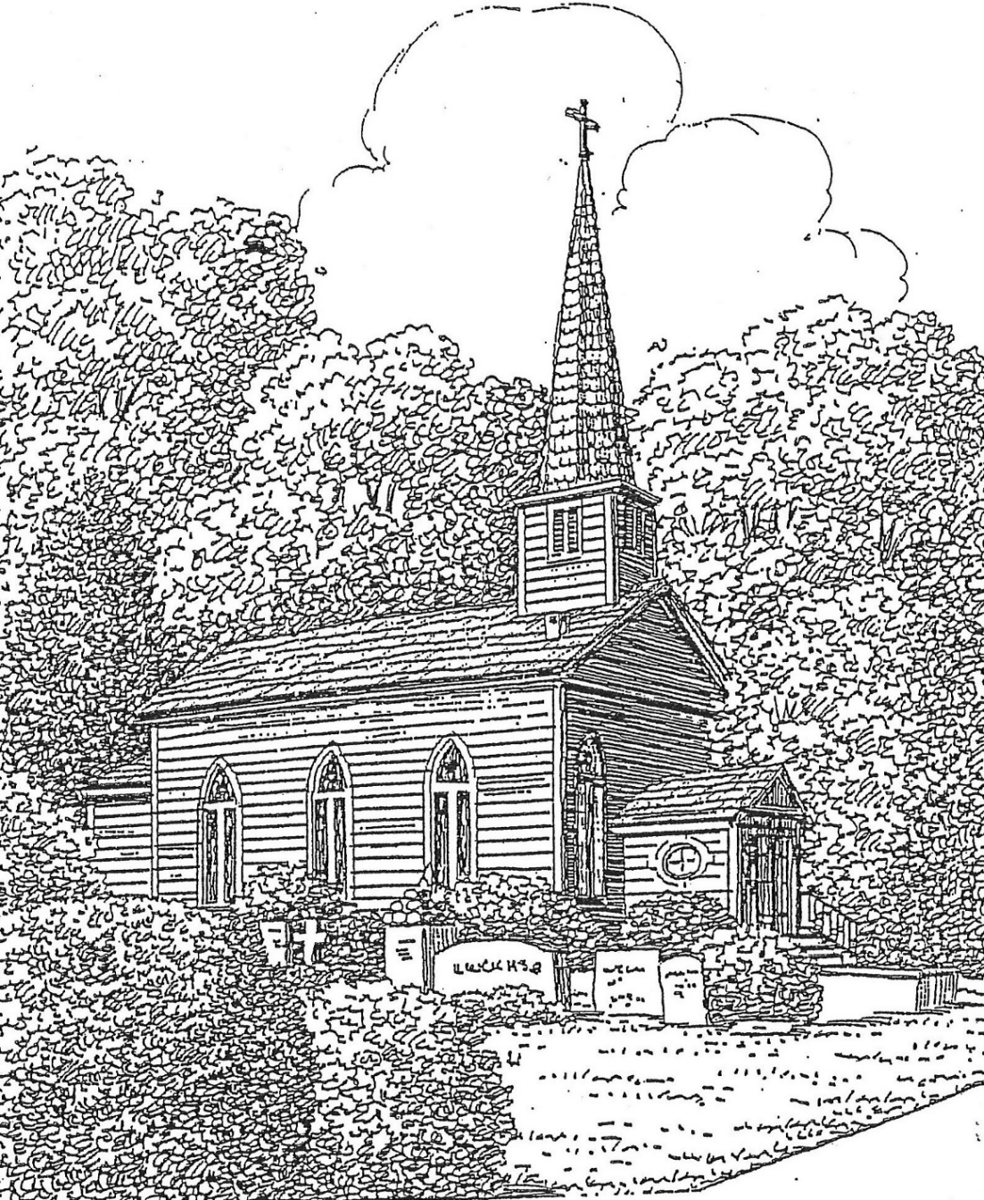

St. Thomas’ Episcopal Church
302 South Queen St.
Windsor, NC 27983
(252) 794-3420

www.stthomaswindsor.org
stthomasbiblestudy.com
email: stthomaschurch1@embarqmail.com

Officiant: The Rev. Bonnie Smith Organist and Soloist: Tom Parker

The Twelfth Sunday after Pentecost
August 23, 2020

Morning Prayer: Rite Two

Prelude Meditation Becker

427 Hymn When morning gilds the skies Laudes Domini

1 When morning gilds the skies,
my heart, awaking, cries,
may Jesus Christ be praised!
When evening shadows fall,
this rings my curfew call,
may Jesus Christ be praised!
5 Sing, suns and stars of space,
sing, ye that see his face,
sing, Jesus Christ be praised!
God's whole creation o'er,
both now and evermore
shall Jesus Christ be praised!
Opening sentence p. 78
Grace to you and peace from God our Father and from the Lord Jesus Christ. Philippians 1:2

Confession of Sin
Let us confess our sins against God and our neighbor.

Silence may be kept.

Minister and People:

Most merciful God,
we confess that we have sinned against you
in thought, word, and deed,
by what we have done,
and by what we have left undone.

We have not loved you with our whole heart;
we have not loved our neighbors as ourselves.

We are truly sorry and we humbly repent.

For the sake of your Son Jesus Christ,
have mercy on us and forgive us;
that we may delight in your will,
and walk in your ways,
to the glory of your Name. Amen.

The Bishop when present, or the Priest, stands and says
Almighty God have mercy on you, forgive you all your sins through our Lord Jesus Christ, strengthen you in all goodness, and by the power of the Holy Spirit keep you in eternal life. Amen.

The Invitatory and Psalter

Officiant Lord, open our lips. p. 80

People And our mouth shall proclaim your praise.

Officiant and People

Glory to the Father, and to the Son, and to the Holy Spirit:

As it was in the beginning, is now, and will be for ever. Amen.

Worship the Lord in the beauty of holiness: Come let us adore him.

S 37 The Venite 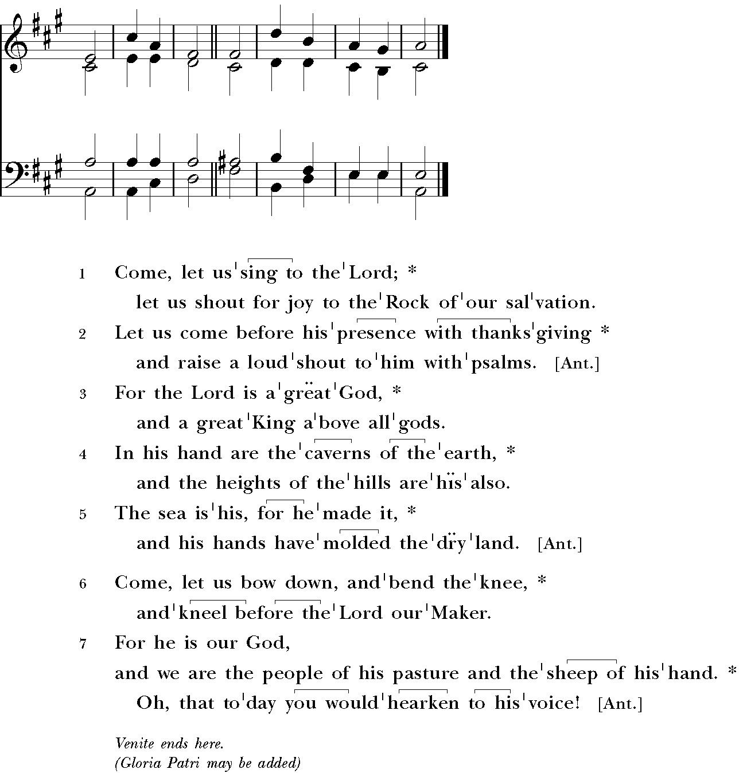

Psalm 124

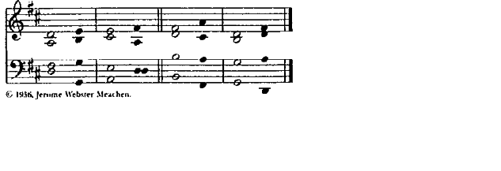

¹ If the Lord had not been on our side, *
let Israel now say;
² If the Lord had not been on our side, *
when enemies rose up against us;
³ Then would they have swallowed us up alive *
in their fierce anger toward us;
⁴ Then would the waters have overwhelmed us *
and the torrent gone over us;
⁵ Then would the raging waters *
have gone right over us.
⁶ Blessed be the Lord! *
he has not given us over to be a prey for their teeth.
⁷ We have escaped like a bird from the snare of the fowler; *
the snare is broken, and we have escaped.
⁸ Our help is in the Name of the Lord, *
the maker of heaven and earth.
Glory to the Father, and to the Son, and to the Holy Spirit: *
as it was in the beginning, is now, and will be for ever. A-men.

The First Lesson Exodus 1:8-2:10

A reading from the book of Exodus.

Now a new king arose over Egypt, who did not know Joseph. He said to his people, “Look, the Israelite people are more numerous and more powerful than we. Come, let us deal shrewdly with them, or they will increase and, in the event of war, join our enemies and fight against us and escape from the land.” Therefore they set taskmasters over them to oppress them with forced labor. They built supply cities, Pithom and Rameses, for Pharaoh. But the more they were oppressed, the more they multiplied and spread, so that the Egyptians came to dread the Israelites. The Egyptians became ruthless in imposing tasks on the Israelites, and made their lives bitter with hard service in mortar and brick and in every kind of field labor. They were ruthless in all the tasks that they imposed on them.
The king of Egypt said to the Hebrew midwives, one of whom was named Shiphrah and the other Puah, “When you act as midwives to the Hebrew women, and see them on the birthstool, if it is a boy, kill him; but if it is a girl, she shall live.” But the midwives feared God; they did not do as the king of Egypt commanded them, but they let the boys live. So the king of Egypt summoned the midwives and said to them, “Why have you done this, and allowed the boys to live?” The midwives said to Pharaoh, “Because the Hebrew women are not like the Egyptian women; for they are vigorous and give birth before the midwife comes to them.” So God dealt well with the midwives; and the people multiplied and became very strong. And because the midwives feared God, he gave them families. Then Pharaoh commanded all his people, “Every boy that is born to the Hebrews you shall throw into the Nile, but you shall let every girl live.”
Now a man from the house of Levi went and married a Levite woman. The woman conceived and bore a son; and when she saw that he was a fine baby, she hid him three months. When she could hide him no longer she got a papyrus basket for him, and plastered it with bitumen and pitch; she put the child in it and placed it among the reeds on the bank of the river. His sister stood at a distance, to see what would happen to him.
The daughter of Pharaoh came down to bathe at the river, while her attendants walked beside the river. She saw the basket among the reeds and sent her maid to bring it. When she opened it, she saw the child. He was crying, and she took pity on him, “This must be one of the Hebrews’ children,” she said. Then his sister said to Pharaoh’s daughter, “Shall I go and get you a nurse from the Hebrew women to nurse the child for you?” Pharaoh’s daughter said to her, “Yes.” So the girl went and called the child’s mother. Pharaoh’s daughter said to her, “Take this child and nurse it for me, and I will give you your wages.” So the woman took the child and nursed it. When the child grew up, she brought him to Pharaoh’s daughter, and she took him as her son. She named him Moses, “because,” she said, “I drew him out of the water.”
Lector The word of the Lord.
People Thanks be to God

S280 Canticle 20 Glory to God Powell

Glory to God in the highest,
and peace to his people on earth.

Lord God, heavenly King,
almighty God and Father,
we worship you, we give you thanks,
we praise you for your glory.

Lord Jesus Christ, only Son of the Father,

Lord God, Lamb of God,
you take away the sin of the world:
have mercy on us;
you are seated at the right hand of the Father:
receive our prayer.

For you alone are the Holy One,
you alone are the Lord,
you alone are the Most High,

Jesus Christ,
with the Holy Spirit,
in the glory of God the Father. Amen.

The Second Lesson Romans 12:1-8

A reading from the Letter of Paul to the Romans.

I appeal to you therefore, brothers and sisters, by the mercies of God, to present your bodies as a living sacrifice, holy and acceptable to God, which is your spiritual worship. Do not be conformed to this world, but be transformed by the renewing of your minds, so that you may discern what is the will of God-- what is good and acceptable and perfect.
For by the grace given to me I say to everyone among you not to think of yourself more highly than you ought to think, but to think with sober judgment, each according to the measure of faith that God has assigned. For as in one body we have many members, and not all the members have the same function, so we, who are many, are one body in Christ, and individually we are members one of another. We have gifts that differ according to the grace given to us: prophecy, in proportion to faith; ministry, in ministering; the teacher, in teaching; the exhorter, in exhortation; the giver, in generosity; the leader, in diligence; the compassionate, in cheerfulness.

Lector The word of the Lord.
People Thanks be to God

S 43 Be Joyful In The Lord
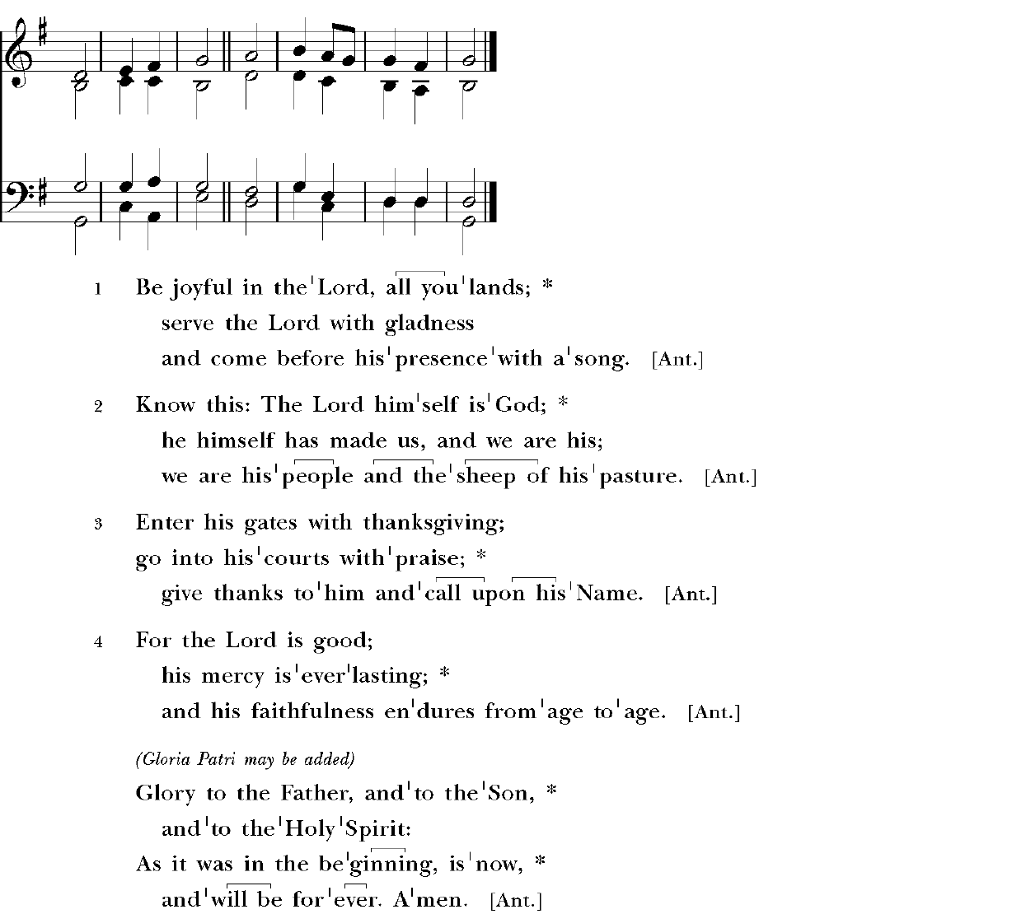

The Gospel Matthew 16:13-20

A reading from the Gospel of Matthew.

When Jesus came into the district of Caesarea Philippi, he asked his disciples, “Who do people say that the Son of Man is?” And they said, “Some say John the Baptist, but others Elijah, and still others Jeremiah or one of the prophets.” He said to them, “But who do you say that I am?” Simon Peter answered, “You are the Messiah, the Son of the living God.” And Jesus answered him, “Blessed are you, Simon son of Jonah! For flesh and blood has not revealed this to you, but my Father in heaven. And I tell you, you are Peter, and on this rock I will build my church, and the gates of Hades will not prevail against it. I will give you the keys of the kingdom of heaven, and whatever you bind on earth will be bound in heaven, and whatever you loose on earth will be loosed in heaven.” Then he sternly ordered the disciples not to tell anyone that he was the Messiah.

Lector The word of the Lord.
People Thanks be to God

Sermon

The Apostles’ Creed p. 96
Officiant and People together

I believe in God, the Father almighty,
creator of heaven and earth.

I believe in Jesus Christ, his only Son, our Lord.

He was conceived by the power of the Holy Spirit
and born of the Virgin Mary.

He suffered under Pontius Pilate,
was crucified, died, and was buried.

He descended to the dead.

On the third day he rose again.

He ascended into heaven,
and is seated at the right hand of the Father.

He will come again to judge the living and the dead.

I believe in the Holy Spirit,
the holy catholic Church,
the communion of saints,
the forgiveness of sins,
the resurrection of the body,
and the life everlasting. Amen.

The Prayers

Officiant The Lord be with you. p. 97

People And also with you.
Officiant Let us pray.

Our Father, who art in heaven,
hallowed be thy Name, thy kingdom come,
thy will be done, on earth as it is in heaven.
Give us this day our daily bread.
And forgive us our trespasses,
as we forgive those who trespass against us.
And lead us not into temptation,
but deliver us from evil.
For thine is the kingdom,
and the power, and the glory, for ever and ever. Amen.

Then follows one of these sets of Suffrages

A
V. Show us your mercy, O Lord;

R. And grant us your salvation.
V. Clothe your ministers with righteousness;

R. Let your people sing with joy.
V. Give peace, O Lord, in all the world;

R. For only in you can we live in safety.
V. Lord, keep this nation under your care;

R. And guide us in the way of justice and truth.
V. Let your way be known upon earth;

R. Your saving health among all nations.
V. Let not the needy, O Lord, be forgotten;

R. Nor the hope of the poor be taken away.
V. Create in us clean hearts, O God;

R. And sustain us with your Holy Spirit

The Collect of the Day
Grant, O merciful God, that your Church, being gathered together in unity by your Holy Spirit, may show forth your power among all peoples, to the glory of your Name; through Jesus Christ our Lord, who lives and reigns with you and the Holy Spirit, one God, for ever and ever. Amen.

A Collect for Sundays p. 98
O God, you make us glad with the weekly remembrance of the glorious resurrection of your Son our Lord: Give us this day such blessing through our worship of you, that the week to come may be spent in your favor; through Jesus Christ our Lord. Amen.

A Collect for Peace p. 99
O God, the author of peace and lover of concord, to know you is eternal life and to serve you is perfect freedom: Defend us, your humble servants, in all assaults of our enemies; that we, surely trusting in your defense, may not fear the power of any adversaries; through the might of Jesus Christ our Lord. Amen.

A Collect for Grace p. 100
Lord God, almighty and everlasting Father, you have brought us in safety to this new day: Preserve us with your mighty power, that we may not fall into sin, nor be overcome by adversity; and in all we do, direct us to the fulfilling of your purpose; through Jesus Christ our Lord. Amen.

Prayer for Mission p. 101
Lord Jesus Christ, you stretched out your arms of love on the hard wood of the cross that everyone might come within the reach of your saving embrace: So clothe us in your Spirit that we, reaching forth our hands in love, may bring those who do not know you to the knowledge and love of you; for the honor of your Name. Amen.

Hymn 525 The church’s one foundation Aurelia

1 The Church's one foundation
is Jesus Christ her Lord;
she is his new creation
by water and the word:
from heaven he came and sought her
to be his holy bride;
with his own blood he bought her,
and for her life he died.
5 Yet she on earth hath union
with God, the Three in One,
and mystic sweet communion
with those whose rest is won.
O happy ones and holy!
Lord, give us grace that we
like them, the meek and lowly,
on high may dwell with thee.
For the Human Family p. 815
O God, you made us in your own image and redeemed us through Jesus your Son: Look with compassion on the whole human family; take away the arrogance and hatred which infect our hearts; break down the walls that separate us;
unite us in bonds of love; and work through our struggle and confusion to accomplish your purposes on earth; that, in your good time, all nations and races may serve you in harmony around your heavenly throne; through Jesus Christ our Lord. Amen.

For the Sick p. 459
Heavenly Father, giver of life and health: Comfort and relieve your sick servants
Katherine Ward, Ashley Burnett, Jeanine Wilson, Al Cowand, Randy Tyler, Ben Procter, Joan Leggett, Kay Barnacascel, Becky Godwin, John Tolbert, Coley McCally, Karen Gudiksen, Bobbie and Rendol Cobb, Libby Smith, Marian Watts, Lena Evans, Charles Taylor Spruill, Larry Watson, Julia Credle, Joey Ezelle, Racheal Coward, Peggy Parker, Karol McLaughlen, Sylvia Dawson, David Dunn, Elsie Benson, Hunter Stone, Brian Stone, Riley Raines, Barbara Ward, those who are suffering from COVID-19, and others known to us,
and give your power of healing to those who minister to their needs, that they may be strengthened in their weakness and have confidence in your loving care; through Jesus Christ our Lord. Amen.

A Prayer from Episcopal Relief and Development (revised)
Compassionate God, source of all comfort, we pray for the people whose lives have been devastated by recent disasters of hurricane, tornado, and fire. Bring them comfort, we pray. Protect the vulnerable. Strengthen the weak. Have mercy on all those working to provide relief and to feed the hungry. And may our response to their suffering be generous and bring you praise. For we ask it in Jesus’ Name. Amen.

For Schools and Colleges p. 824
O Eternal God, bless all schools, colleges, and universities[especially at the beginning of the new school year], that they may be lively centers for sound learning, new discovery, and the pursuit of wisdom; and grant that those who teach and those who learn may find you to be the source of all truth; through Jesus Christ our Lord. Amen.

Authorized intercessions and thanksgivings may follow.

The General Thanksgiving p. 101

Officiant and People

Almighty God, Father of all mercies,
we your unworthy servants give you humble thanks
for all your goodness and loving-kindness
to us and to all whom you have made.

We bless you for our creation, preservation,
and all the blessings of this life;
but above all for your immeasurable love
in the redemption of the world by our Lord Jesus Christ;
for the means of grace, and for the hope of glory.

And, we pray, give us such an awareness of your mercies,
that with truly thankful hearts we may show forth your praise,
not only with our lips, but in our lives
by giving up our selves to your service,
and by walking before you
in holiness and righteousness all our days;
through Jesus Christ our Lord,
to whom, with you and the Holy Spirit,
be honor and glory throughout all ages. Amen.

A Prayer of St. Chrysostom p. 102
Almighty God, you have given us grace at this time with one accord to make our common supplication to you; and you have promised through your well-beloved Son that when two or three are gathered together in his Name you will be in the midst of them: Fulfill now, O Lord, our desires and petitions as may be best for us; granting us in this world knowledge of your truth, and in the age to come life everlasting. Amen.

Let us bless the Lord.
Thanks be to God.

The Officiant may then conclude with the following
Glory to God whose power, working in us, can do infinitely more than we can ask or imagine: Glory to him from generation to generation in the Church, and in Christ Jesus for ever and ever. Amen. Ephesians 3:20, 21

Hymn 518 Christ is made the sure foundation Westminster Abbey

1 Christ is made the sure foundation,
Christ the head and cornerstone,
chosen of the Lord, and precious,
binding all the Church in one;
holy Zion's help for ever,
and her confidence alone.
4 Here vouchsafe to all thy servants
what they ask of thee to gain;
what they gain from thee, for ever
with the blessèd to retain,
and hereafter in thy glory
evermore with thee to reign.
Postlude Mazurka Chopin/arr. Kimball

ANNOUNCEMENTS

St. Thomas’ Church, Windsor, will continue with online worship each Sunday.

Hymns and music are in the public domain.

Offerings to St. Thomas’ Church can be mailed to St. Thomas’ Episcopal Church, PO Box 400, Windsor, NC 27983. You may also use that address to set up online bill pay with your bank.

Lector: Tra Perry

Clergy in Windsor are inviting our members to unite in prayer wherever you are on Wednesdays at noon. Join St. Thomas’ Church on Facebook Live:
https://www.facebook.com/St-Thomas-Episcopal-Church-Windsor-NC-218496044881921

If you have a name to add or remove from the prayer list, please email stthomaschurch1@embarqmail.com or bonniejsmith19@gmail.com .

All worship videos from St. Thomas’ Church can be found here:
https://www.facebook.com/pg/St-Thomas-Episcopal-Church-Windsor-NC-218496044881921/videos/?ref=page_internal
If you do not have sound, look for the speaker/megaphone icon on the lower right and click on it to change the “X” to a volume control.

Please continue to check for updates on our Facebook and web pages.
Facebook: https://www.facebook.com/St-Thomas-Episcopal-Church-Windsor-NC-218496044881921
Web site: http://stthomaswindsor.org/

The St. Thomas bible study web site posts the Sunday lectionary readings and related art slides: https://stthomasbiblestudy.com/lectionary-readings/

You can also download the Book of Common Prayer or view it online:
Download: https://www.churchpublishing.org/siteassets/pdf/book-of-common-prayer/book-of-common-prayer-2006.pdf
Online: www.bcponline.org

