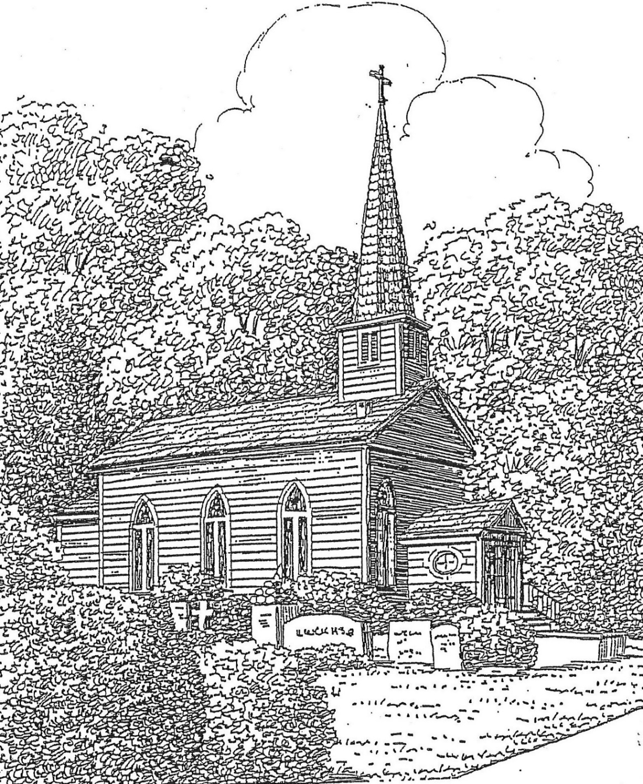

St. Thomas’ Episcopal Church
302 South Queen St.
Windsor, NC 27983
(252) 794-3420

www.stthomaswindsor.org
stthomasbiblestudy.com
email: stthomaschurch1@embarqmail.com

Officiant: The Rev. Bonnie Smith Organist and Soloist: Tom Parker
The Fifth Sunday of Easter
May 10, 2020

Morning Prayer: Rite Two

Prelude Interlude Perks

47 Hymn On this day, the first of days Gott sei Dank

1 On this day, the first of days,
God the Father's Name we praise,
who, creation's Lord and spring,
did the world from darkness bring.

2 On this day the eternal Son
over death his triumph won;
on this day the Spirit came
with his gifts of living flame.

3 Maker, who didst fashion me
image of thyself to be,
fill me with thy love divine,
let my every thought be thine.

4 Holy Jesus, may I be
dead and buried here with thee;
and, by love inflamed, arise
unto thee a sacrifice.

5 Thou who dost all gifts impart,
shine, blest Spirit, in my heart;
best of gifts, thyself bestow;
make me burn thy love to know.

6 God, the blessèd Three in One,
dwell within my heart alone;
thou dost give thyself to me,
may I give myself to thee.

Opening sentence p. 77
On this day the Lord has acted; we will rejoice and be glad in it. Psalm 118:24

The Invitatory and Psalter

Officiant Lord, open our lips. p. 80

People And our mouth shall proclaim your praise.

Officiant and People

Glory to the Father, and to the Son, and to the Holy Spirit:

As it was in the beginning, is now, and will be for ever. Amen.

Easter antiphon Alleluia. The Lord is risen indeed: Come let us adore him. Alleluia.

W880 The Easter Canticle Pascha Nostrum Sine Nomine

God's Paschal Lamb is sacrificed for us;
therefore with joy we keep the Easter feast;
forsaking sin, we share the bread of truth.
Alleluia, alleluia!

Now Christ is raised and will not die again;
death has no more dominion over him;
through him we die to sin and live to God.
Alleluia, alleluia!

In Christ we see the first fruits of the dead
though Adam's sin had doomed all flesh to die,
in Christ's new life shall all be made alive.
Alleluia, alleluia!

Psalm 31:1-5, 15-16

¹ In you, O Lord, have I taken refuge; let me never be put to shame; *
deliver me in your righteousness.
² Incline your ear to me; *
make haste to deliver me.
³ Be my strong rock, a castle to keep me safe, for you are my crag and my stronghold; *
for the sake of your Name, lead me and guide me.
⁴ Take me out of the net that they have secretly set for me, *
for you are my tower of strength.
⁵ Into your hands I commend my spirit, *
for you have redeemed me, O Lord, O God of truth.
¹⁵ My times are in your hand; *
rescue me from the hand of my enemies, and from those who persecute me.
¹⁶ Make your face to shine upon your servant, *
and in your loving-kindness save me."
Glory to the Father, and to the Son, and to the Holy Spirit: *
as it was in the beginning, is now, and will be for ever. A-men.

The First Lesson Acts 7:55-60

A reading from the Acts of the Apostles.

Filled with the Holy Spirit, Stephen gazed into heaven and saw the glory of God and Jesus standing at the right hand of God. “Look,” he said, “I see the heavens opened and the Son of Man standing at the right hand of God!” But they covered their ears, and with a loud shout all rushed together against him. Then they dragged him out of the city and began to stone him; and the witnesses laid their coats at the feet of a young man named Saul. While they were stoning Stephen, he prayed, “Lord Jesus, receive my spirit.” Then he knelt down and cried out in a loud voice, “Lord, do not hold this sin against them.” When he had said this, he died.
Lector The word of the Lord.
People Thanks be to God

Canticle 8 The Song of Moses Cantemus Domino p. 85
Exodus 15:1-6, 11-13, 17-18
Especially suitable for use in Easter Season
I will sing to the Lord, for he is lofty and uplifted; *
the horse and its rider has he hurled into the sea.
The Lord is my strength and my refuge; *
the Lord has become my Savior.
This is my God and I will praise him, *
the God of my people and I will exalt him.
The Lord is a mighty warrior; *
Yahweh is his Name.
The chariots of Pharaoh and his army has he hurled into the sea; *
the finest of those who bear armor have been drowned in the Red Sea.
The fathomless deep has overwhelmed them; *
they sank into the depths like a stone.
Your right hand, O Lord, is glorious in might; *
your right hand, O Lord, has overthrown the enemy.
Who can be compared with you, O Lord, among the gods? *
who is like you, glorious in holiness,
awesome in renown, and worker of wonders?
You stretched forth your right hand; *
the earth swallowed them up.
With your constant love you led the people you redeemed; *
with your might you brought them in safety to your holy dwelling.
You will bring them in and plant them *
on the mount of your possession,
The resting-place you have made for yourself, O Lord, *
the sanctuary, O Lord, that your hand has established.
The Lord shall reign *
for ever and for ever.
Glory to the Father, and to the Son, and to the Holy Spirit: *
as it was in the beginning, is now, and will be for ever. Amen.

The Second Lesson 1 Peter 2:2-10

A reading from the First Letter of Peter.

Like newborn infants, long for the pure, spiritual milk, so that by it you may grow into salvation— if indeed you have tasted that the Lord is good.
Come to him, a living stone, though rejected by mortals yet chosen and precious in God’s sight, and like living stones, let yourselves be built into a spiritual house, to be a holy priesthood, to offer spiritual sacrifices acceptable to God through Jesus Christ. For it stands in scripture:
“See, I am laying in Zion a stone,
a cornerstone chosen and precious;
and whoever believes in him will not be put to shame.”
To you then who believe, he is precious; but for those who do not believe,
“The stone that the builders rejected
has become the very head of the corner”,
And “A stone that makes them stumble,
and a rock that makes them fall.”
They stumble because they disobey the word, as they were destined to do.
But you are a chosen race, a royal priesthood, a holy nation, God’s own people, in order that you may proclaim the mighty acts of him who called you out of darkness into his marvelous light.
Once you were not a people,
but now you are God’s people;
once you had not received mercy,
but now you have received mercy.

Lector The word of the Lord.
People Thanks be to God

S280 Canticle 20 Glory to God Powell

Glory to God in the highest,
and peace to his people on earth.

Lord God, heavenly King,
almighty God and Father,
we worship you, we give you thanks,
we praise you for your glory.

Lord Jesus Christ, only Son of the Father,

Lord God, Lamb of God,
you take away the sin of the world:
have mercy on us;
you are seated at the right hand of the Father:
receive our prayer.

For you alone are the Holy One,
you alone are the Lord,
you alone are the Most High,

Jesus Christ,
with the Holy Spirit,
in the glory of God the Father. Amen.
The Gospel John 14:1-14

A reading from the Gospel of John.
Jesus said, “Do not let your hearts be troubled. Believe in God, believe also in me. In my Father’s house there are many dwelling places. If it were not so, would I have told you that I go to prepare a place for you? And if I go and prepare a place for you, I will come again and will take you to myself, so that where I am, there you may be also. And you know the way to the place where I am going.” Thomas said to him, “Lord, we do not know where you are going. How can we know the way?” Jesus said to him, “I am the way, and the truth, and the life. No one comes to the Father except through me. If you know me, you will know my Father also. From now on you do know him and have seen him.” Philip said to him, “Lord, show us the Father, and we will be satisfied.” Jesus said to him, “Have I been with you all this time, Philip, and you still do not know me? Whoever has seen me has seen the Father. How can you say, ‘Show us the Father’? Do you not believe that I am in the Father and the Father is in me? The words that I say to you I do not speak on my own; but the Father who dwells in me does his works. Believe me that I am in the Father and the Father is in me; but if you do not, then believe me because of the works themselves. Very truly, I tell you, the one who believes in me will also do the works that I do and, in fact, will do greater works than these, because I am going to the Father. I will do whatever you ask in my name, so that the Father may be glorified in the Son. If in my name you ask me for anything, I will do it.”

Lector The word of the Lord.
People Thanks be to God

Sermon

The Apostles’ Creed p. 96
Officiant and People together

I believe in God, the Father almighty,
creator of heaven and earth.

I believe in Jesus Christ, his only Son, our Lord.

He was conceived by the power of the Holy Spirit
and born of the Virgin Mary.

He suffered under Pontius Pilate,
was crucified, died, and was buried.

He descended to the dead.

On the third day he rose again.

He ascended into heaven,
and is seated at the right hand of the Father.

He will come again to judge the living and the dead.

I believe in the Holy Spirit,
the holy catholic Church,
the communion of saints,
the forgiveness of sins,
the resurrection of the body,
and the life everlasting. Amen.

The Prayers

Officiant The Lord be with you. p. 97

People And also with you.
Officiant Let us pray.

Our Father, who art in heaven,
hallowed be thy Name, thy kingdom come,
thy will be done, on earth as it is in heaven.
Give us this day our daily bread.
And forgive us our trespasses,
as we forgive those who trespass against us.
And lead us not into temptation,
but deliver us from evil.
For thine is the kingdom,
and the power, and the glory, for ever and ever. Amen.

Then follows one of these sets of Suffrages

A
V. Show us your mercy, O Lord;

R. And grant us your salvation.
V. Clothe your ministers with righteousness;

R. Let your people sing with joy.
V. Give peace, O Lord, in all the world;

R. For only in you can we live in safety.
V. Lord, keep this nation under your care;

R. And guide us in the way of justice and truth.
V. Let your way be known upon earth;

R. Your saving health among all nations.
V. Let not the needy, O Lord, be forgotten;

R. Nor the hope of the poor be taken away.
V. Create in us clean hearts, O God;

R. And sustain us with your Holy Spirit.

The Collect of the Day Said by all
Almighty God, whom truly to know is everlasting life: Grant us so perfectly to know your Son Jesus Christ to be the way, the truth, and the life, that we may steadfastly follow his steps in the way that leads to eternal life; through Jesus Christ your Son our Lord, who lives and reigns with you, in the unity of the Holy Spirit, one God, for ever and ever. Amen.

A Collect for Sundays p. 98
O God, you make us glad with the weekly remembrance of the glorious resurrection of your Son our Lord: Give us this day such blessing through our worship of you, that the week to come may be spent in your favor; through Jesus Christ our Lord. Amen

A Collect for Peace p. 99
O God, the author of peace and lover of concord, to know you is eternal life and to serve you is perfect freedom: Defend us, your humble servants, in all assaults of our enemies; that we, surely trusting in your defense, may not fear the power of any adversaries; through the might of Jesus Christ our Lord. Amen.

A Collect for Grace p. 100
Lord God, almighty and everlasting Father, you have brought us in safety to this new day: Preserve us with your mighty power, that we may not fall into sin, nor be overcome by adversity; and in all we do, direct us to the fulfilling of your purpose; through Jesus Christ our Lord. Amen.

For the Sick p. 459
Heavenly Father, giver of life and health: Comfort and relieve your sick servants
Katherine Ward, Ashley Burnett, Jeanine Wilson, Al Cowand, Randy Tyler, Ben Procter, Joan Leggett, Kay Barnacascel, Becky Godwin, John Tolbert, Coley McCally, Karen Gudiksen, Bobbie and Rendol Cobb, Libby Smith, Marian Watts, Lena Evans, Charles Taylor Spruill, Larry Watson, Julia Credle, Joey Ezelle, Racheal Coward, Peggy Parker, Karol McLaughlen, Sylvia Dawson, David Dunn, Elsie Benson, Hunter Stone, Brian Stone, Riley Raines, Jack Cooper, Marc Rentzer, those who are suffering from COVID-19, and others known to us,
and give your power of healing to those who minister to their needs, that they may be strengthened in their weakness and have confidence in your loving care; through Jesus Christ our Lord. Amen.

For Doctors and Nurses p. 460
Sanctify, O Lord, those whom you have called to the study and practice of the arts of healing, and to the prevention of disease and pain. Strengthen them by your life-giving Spirit, that by their ministries the health of the community may be
promoted and your creation glorified; through Jesus Christ our Lord. Amen.

For Those Who Have Died p. 498
Father of all, we pray to you for all those whom we love but see no longer, especially those who have died of COVID-19. Grant to them eternal rest. Let light perpetual shine upon them. May their souls and the souls of all the departed, through the mercy of God, rest in peace. Amen.

Prayer for Mission p. 101
Lord Jesus Christ, you stretched out your arms of love on the hard wood of the cross that everyone might come within the reach of your saving embrace: So clothe us in your Spirit that we, reaching forth our hands in love, may bring those who do not know you to the knowledge and love of you; for the honor of your Name. Amen.

Hymn 644 How sweet the Name of Jesus sounds St. Peter

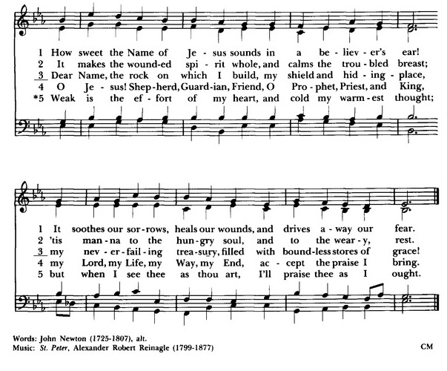

Authorized intercessions and thanksgivings may follow.

The General Thanksgiving p. 101

Officiant and People

Almighty God, Father of all mercies,
we your unworthy servants give you humble thanks
for all your goodness and loving-kindness
to us and to all whom you have made.

We bless you for our creation, preservation,
and all the blessings of this life;
but above all for your immeasurable love
in the redemption of the world by our Lord Jesus Christ;
for the means of grace, and for the hope of glory.

And, we pray, give us such an awareness of your mercies,
that with truly thankful hearts we may show forth your praise,
not only with our lips, but in our lives
by giving up our selves to your service,
and by walking before you
in holiness and righteousness all our days;
through Jesus Christ our Lord,
to whom, with you and the Holy Spirit,
be honor and glory throughout all ages. Amen.

A Prayer of St. Chrysostom p. 102
Almighty God, you have given us grace at this time with one accord to make our common supplication to you; and you have promised through your well-beloved Son that when two or three are gathered together in his Name you will be in the midst of them: Fulfill now, O Lord, our desires and petitions as may be best for us; granting us in this world knowledge of your truth, and in the age to come life everlasting. Amen.

The Officiant may then conclude with the following
Glory to God whose power, working in us, can do infinitely more than we can ask or imagine: Glory to him from generation to generation in the Church, and in Christ Jesus for ever and ever. Amen. Ephesians 3:20, 21

Let us bless the Lord.
Thanks be to God.

Hymn 432 O praise ye the Lord! Praise him in the height Laudate Dominum

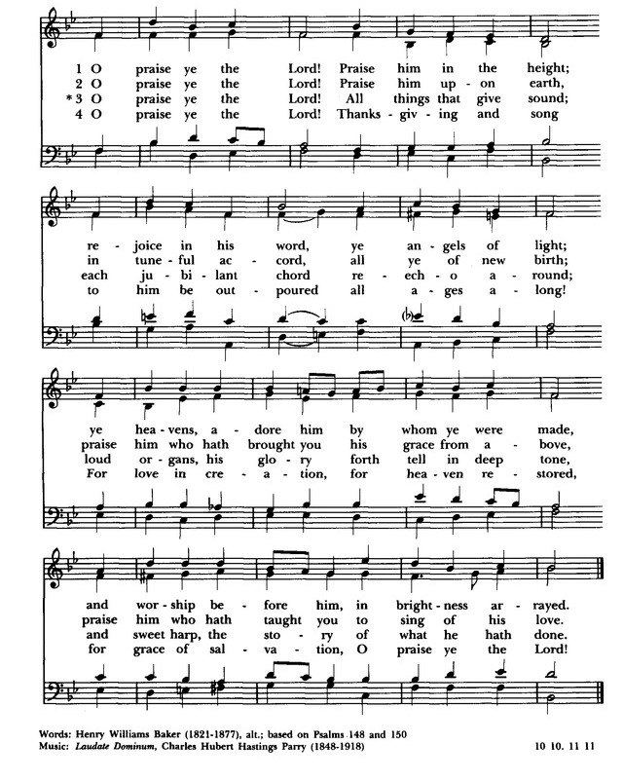

Postlude The Mercy Of The Lord Is Forever Hunnicutt

ANNOUNCEMENTS

Suspension of public worship continues in the Diocese of East Carolina.

The annual Rogation service planned for next Sunday, May 17, will now be an online video with participants from the Episcopal churches in Windsor, Ahoskie, Roxobel, and Lewiston-Woodville. Please send photos of your garden, flowers, farm, or outdoor scenery to bonniejsmith19@gmail.com by Wednesday, May 13.

Hymns and music are in the public domain, except for the words to The Easter Canticle written by Carl P. Daw, Jr. with copyright by Hope Publishing Co. From their website: “For the month of May, we are granting free permission for the live streaming of any copyrights that are owned by Hope Publishing.”

Offerings to St. Thomas’ Church can be mailed to St. Thomas’ Episcopal Church, PO Box 400, Windsor, NC 27983. You may also use that address to set up online bill pay with your bank.

Lector: Jaquelin Perry

Evening prayer is offered by Bishop Skirving or diocesan staff each Wednesday at 7:00 p.m. on Facebook. These services and the April 26 diocesan Morning Prayer can be viewed at any time at https://www.facebook.com/dioec/

If you have a name to add or remove from the prayer list, please email stthomaschurch1@embarqmail.com or bonniejsmith19@gmail.com .

Please continue to check for updates on our Facebook and web pages.
Facebook: https://www.facebook.com/St-Thomas-Episcopal-Church-Windsor-NC-218496044881921
Web site: http://stthomaswindsor.org/

The St. Thomas bible study web site posts the Sunday lectionary readings and related art slides:
https://stthomasbiblestudy.com/lectionary-readings/

You can also download the Book of Common Prayer or view it online:
Download: https://www.churchpublishing.org/siteassets/pdf/book-of-common-prayer/book-of-common-prayer-2006.pdf
Online: www.bcponline.org

