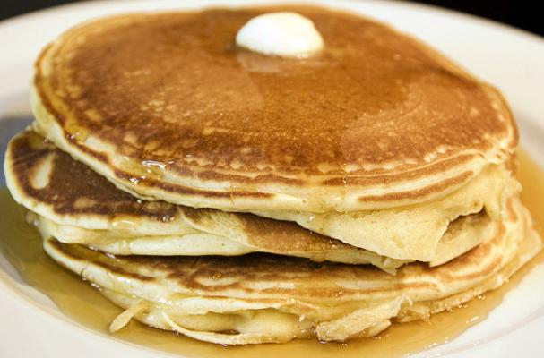

St. Thomas’ Shrove Tuesday
Pancake Supper
February 25
5:00 – 7:00pm

Adults $7.00
Child (ages 3-9) $5.00
Under age 3 Free

Come join us and bring a friend!

